**What does it do?**

First, let’s establish what cloud computing is. The term ‘cloud’ originated as a metaphor for the servers, services and connections composing the web of internet. Nowadays, ‘the cloud’ is used to describe computer-system resources available to ‘rent out’ and to use either for business or even personal use. It is often cheaper and easier to use cloud services due to the scale of such services – the bigger the service, the better value it is. Most typical use-cases are data storage and computing power.

Data storage is a simple one: iCloud, Google Drive, OneDrive are all cloud services designed to be used for data storage. It’s a convenient way to store files as it makes them accessible from anywhere with an internet connection, sharing files is easy and the most of those services are secure, meaning there are layers of protection applied to your files. The data is encrypted – letting only the user access it, keeping snoopy eyes of friends or even hackers away; and is also redundant – stored on multiple servers around the world, which not only allows the users to access their files with low latency from anywhere around the world, but also means that should one server for whatever reason go down or get damaged, all the data is backed up elsewhere and can still be accessed with no issues. Data storage cloud services are easily scalable, if there’s higher demand – simply add more storage to the system. But big corporations with big servers aren’t the only ones who can provide cloud data storage. Torrent is a great example of cloud computing that allows users to view and download data not from a particular server, but from many different personal computers located around the world. The main idea is that the same file is stored on different computers and whenever someone wants to download it, it’s being done so from them and once the download is complete this new computer begins to share the file in the same way as the ones it downloaded it from. 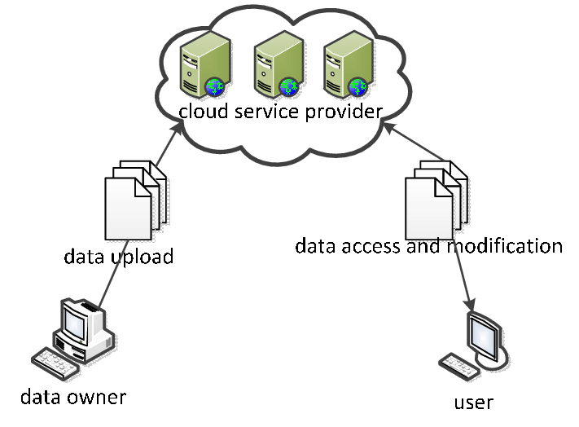

Computing power sharing services provide companies or even individuals to use a higher computing power than that they own. It’s especially convenient for offloading heavy computing tasks infrequently, where purchasing a system to do it onsite might be uneconomical, but even for those who might frequently need such higher computing power might opt in to use the cloud due to it being easier and companies such as IBM constantly upgrading and managing their services, meaning users will never need to worry about their hardware going obsolete and will always get the best available to them. Sharing computing power also doesn’t have to be simply done only by big corporation. Anyone can share the computing power of their computer to be used by others when the computer is not used. Medical research is one of the more common tasks done on personal computers around the world. Cloud computing services are, most of the time are pay as you go, covering the cost of running these services and, in the long run, paying off the cost of rolling such services out.

Overall, cloud is definitely a very good innovation. It affected the majority of our world’s population and in a very good way. It makes work a lot more efficient and simpler. It’s got great prospects for the future where we, one day, might not need to own any sort of computing power of our own, but instead we’ll be able to rely on simple gadgets receiving data and all actual computational work done in the cloud. And given how incredibly fast technology is progressing at the moment, that future might be here sooner than we think.

**What is the likely impact?**

The impact of cloud computing is already prominent and has big potential for the future. At the moment, most people have already used cloud services, sometimes without even realising it. More and more people are being connected to the web and become dependant on such services. There’s becoming less need to own a lot of different devices to achieve different things. There’s less need for storage space due to more things being available through the internet. Have you noticed that even though there’s been so much technological innovation in the past 10 years, a terabyte of storage is still more than enough for most people, even though programs and media is only becoming more complex and should take up more storage? We very quickly have moved from owning copies of movies and downloading MP3s to having all of it available to us through the internet using services like Netflix and Spotify, which are a form of cloud computing as well. In gaming, LAN parties are virtually a thing of the past. First game servers were created, where people can play together from different parts of the world, now games as a whole are being moved to cloud through services like Google Stadia and GeForce Now, allowing users to play games from almost any device with an internet connection and without the need to own a beefy gaming computer or to download games. Cloud computing is growing at a humongous rate with great implications. In the future, there won’t be a need to ‘compute’ anything on devices you own. It is more efficient, less power consuming and more convenient to offload all of the tasks into the cloud. However, all great things come at a cost and with danger. Since cloud computing is available on and connected to the internet, it can be misused by hackers and the companies themselves. We are trusting way too much of out personal and valuable information to services. The more we become connected to those services, the more information there is on us available on the internet. Data hoarding is an already existing real issue, where companies or sometimes even governments collect as much data as they can on individuals. Technology is growing faster than we can adapt to it. There are always big processes to establish regulations and rules about such things and while new laws are being written, a new piece of tech is already being misused.

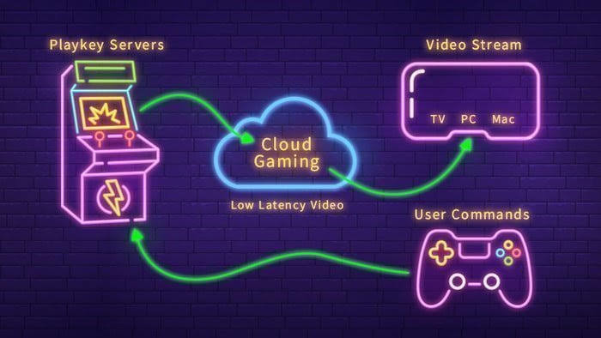

**How will this affect you?**

Personally for me, this will bring more convenience than ever. Google Drive, Netflix, Wikipedia and many more other services have become a big part of my digital life and now it’s hard to imagine, not only the internet, but the world without them. The ability to communicate and collaborate with others around the world, sharing data, collecting information is evolving and growing. I live in Australia and I am able to talk and even play games with my dad, it’s honestly hard to imagine life before cloud computing and internet as a whole became a reality. If you look even at our life right now, we are all relying on the cloud more than ever: people are working and studying from home, watching movies and playing games. Self isolation because of COVID-19 to this extent wouldn’t be possible 15 or maybe even 10 years ago. We depend on technology and cloud more than ever before and that dependence will only grow stronger as time moves forward. An interesting detail about cloud is even though so many people rely so heavily on it right now, most don’t even know what it really is and that’s the beauty of it. If done right, it is so easy to use you don’t even have to realise that you’re currently ‘in the cloud’. The prospect of not needing to own a computer, and relying solely on the cloud, but still be able to do all the things I need and more is great. My day to day life will become more efficient and easier.

**Bibliography**

Ranger, S., 2021. What is cloud computing? Everything you need to know about the cloud explained | ZDNet. [online] ZDNet. Available at: <<https://www.zdnet.com/article/what-is-cloud-computing-everything-you-need-to-know-about-the-cloud/>> [Accessed 12 April 2021].

Azure.microsoft.com. 2021. What is cloud computing? A beginner’s guide | Microsoft Azure. [online] Available at: <<https://azure.microsoft.com/en-au/overview/what-is-cloud-computing/>> [Accessed 12 April 2021].

Youtube.com. 2021. What is Cloud Computing?. [online] Available at: <<https://www.youtube.com/watch?v=dH0yz-Osy54>> [Accessed 12 April 2021].

Accenture.com. 2021. What is Cloud Computing & Why is it Important? | Accenture. [online] Available at: < <https://www.accenture.com/au-en/insights/cloud-computing-index>> [Accessed 12 April 2021].

Researchgate.net. 2021. Data sharing model in cloud computing mode. [online] Available at: <<https://www.researchgate.net/figure/Data-sharing-model-in-cloud-computing-mode_fig1_334329125>> [Accessed 1 May 2021].

researchgate.net. 2021. Data sharing model in cloud computing mode. [online] Available at: <<https://www.researchgate.net/figure/Data-sharing-model-in-cloud-computing-mode_fig1_334329125>> [Accessed 1 May 2021].